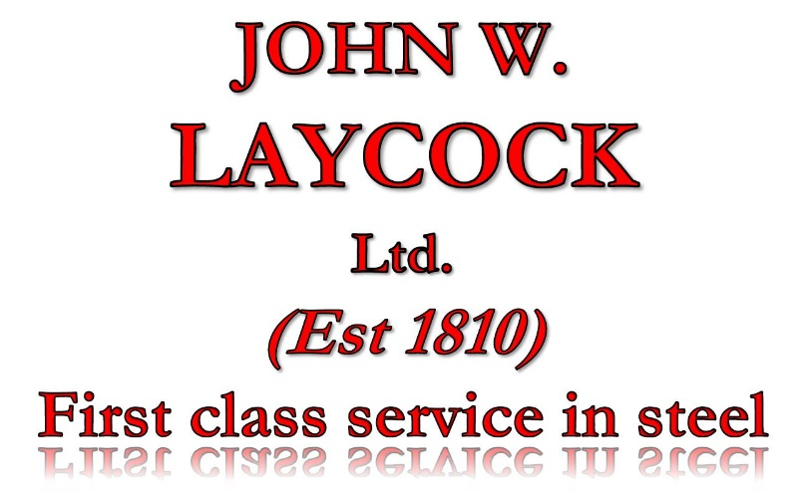
STOCKBRIDGE WORKS
BRADFORD ROAD
KEIGHLEY
WEST YORKSHIRE
BD21 4EH

TEL. 01535 667033
FAX. 01535 611160
EMAIL. sales@johnwlaycock.co.uk
WEB. www.johnwlaycock.co.uk

Environmental Policy

Aim of the environmental policy

JOHN W. LAYCOCK Ltd. is committed to minimising the environmental impact of its operations through the adoption of sustainable practices and continual improvement in environmental performance. We accept the 'Duty of Care' imposed by legislation as the minimum standard to be set and maintained, and we aim to develop a sustainable business that is financially viable, environmentally sustainable and socially equitable.

In order to achieve this the Company will observe the following practices:

- be conscious of the environment beyond our immediate operations and to take steps to prevent pollution and to minimise environmental harm and nuisance;

- monitor and comply with legislation, regulations and codes of practice on environmental matters relevant to its operations;

- build an environmentally friendly work culture through training and high quality communication with staff and all stakeholders;

- monitor, review and continually improve our environmental performance;

- be proactive in minimising our production of waste and reusing or recycling materials;

- work in partnership with external stakeholders to develop our corporate social responsibility.

Mark Sugden
Director

